Lab 3 - Routing Protocol

NAME: LAU YEE WEN
MATRIC NUM.: A23CS0099
SECTION: 12
INTRODUCTION
This lab looks into the network layer, focusing on subnetting and routing.

TOPOLOGY

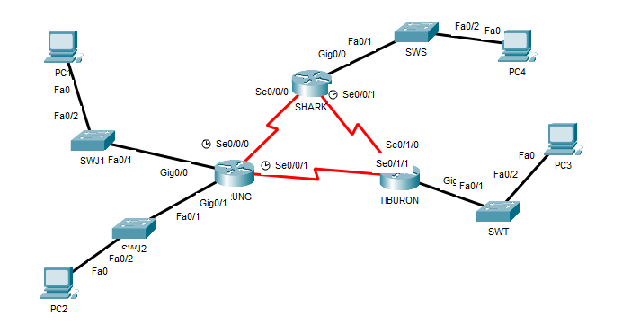

LAB INFORMATION
Here is some basic information for the lab. The network address given is 172.18.110.0/23.
Table 1

Device | Subnetwork | Usable Hosts
JERUNG | LAN1 | 20
 | LAN2 | 30
SHARK | LAN | 60
TIBURON | LAN | 50
Connections | JERUNG-SHARK | 2
 | JERUNG-TIBURON | 2
 | SHARK-TIBURON | 2

Table 2

# | Device  Name | Interface | IP Address | Subnet Mask | Gateway
1 | JERUNG | Se0/0/0 | 172.18.110.193 | 255.255.255.252 | -
2 |  | Se0/0/1 | 172.18.110.197 | 255.255.255.252 | -
3 |  | G0/0 | 172.18.110.1 | 255.255.255.224 | -
4 |  | G0/1 | 172.18.110.33 | 255.255.255.224 | -
5 | TIBURON | Se0/1/1 | 172.18.110.198 | 255.255.255.252 | -
6 |  | Se0/1/0 | 172.18.110.202 | 255.255.255.252 | -
7 |  | G0/0 | 172.18.110.129 | 255.255.255.192 | -
8 | SHARK | Se0/0/0 | 172.18.110.194 | 255.255.255.252 | -
9 |  | Se0/0/1 | 172.18.110.201 | 255.255.255.252 | -
10 |  | G0/0 | 172.18.110.65 | 255.255.255.192 | -
11 | PC1 | - | 172.18.110.30 | 255.255.255.224 | 172.18.110.1
12 | PC2 | - | 172.18.110.62 | 255.255.255.224 | 172.18.110.33
13 | PC3 | - | 172.18.110.190 | 255.255.255.192 | 172.18.110.129
14 | PC4 | - | 172.18.110.126 | 255.255.255.192 | 172.18.110.65

LAB TASKS

Task 1 – IP Addressing
- Given the network address of the organisation and the basic information provided in both Tables 1 and 2. Show your workings here and complete Table 2 with the correct information. PCs will be given the last usable address of the subnetwork.

- JERUNG LAN1 (20 hosts): /27 (32 IPs, 30 usable IPs) 172.18.110.0/27 (172.18.110.1- 172.18.110.30)
2⁵= 32
Subnet mask: /27
Usable IPs: 32-2= 30

- JERUNG LAN2 (30 hosts): /27 (32 IPs, 30 usable IPs) 172.18.110.32/27 (172.18.110.33- 172.18.110.62)
2⁵= 32
Subnet mask: /27
Usable IPs: 32-2= 30

- SHARK LAN (60 hosts): /26 (64 IPs, 62 usable IPs) 172.18.110.64/26 (172.18.110.65- 172.18.110.126)
2⁶= 64
Subnet mask: /26
Usable IPs: 64-2= 62

- TIBURON LAN (50 hosts): /26 (64 IPs, 62 usable IPs) 172.18.110.128/26 (172.18.110.129- 172.18.110.190)
2⁶= 64
Subnet mask: /26
Usable IPs: 64-2= 62

- Point-to-Point Links (JERUNG-SHARK, JERUNG-TIBURON, SHARK-TIBURON): 2 hosts each /30 (4 IPs, 2 usable IPs).

- JERUNG-SHARK: 172.18.110.192/30 → Usable: (172.18.110.193 – 172.18.110.194)
- JERUNG-TIBURON: 172.18.110.196/30 → Usable: 172.18.110.197 – 172.18.110.198
- SHARK-TIBURON: 172.18.110.200/30 → Usable: 172.18.110.201 – 172.18.110.202

2²= 4
Subnet mask: /30
Usable IPs: 4-2= 2

Device | Subnetwork | Prefix | Subnet Mask | Network Address | Usable IP Range
JERUNG | LAN1 | /27 | 11111111. 11111111. 11111111. 11100000  =255.255.255.224 | 172.18.110.0 | 172.18.110.1 - 172.18.110.30
 | LAN2 | /27 | 11111111. 11111111. 11111111. 11100000  =255.255.255.224 | 172.18.110.32 | 172.18.110.33 - 172.18.110.62
SHARK | LAN | /26 | 11111111. 11111111. 11111111. 11000000  =255.255.255.192 | 172.18.110.64 | 172.18.110.65 - 172.18.110.126
TIBURON | LAN | /26 | 11111111. 11111111. 11111111. 11000000  =255.255.255.192 | 172.18.110.128 | 172.18.110.129 - 172.18.110.190
Connections | JERUNG-SHARK | /30 | 11111111. 11111111. 11111111. 11111100  =255.255.255.252 | 172.18.110.192 | 172.18.110.193 - 172.18.110.194
 | JERUNG-TIBURON | /30 | 11111111. 11111111. 11111111. 11111100  =255.255.255.252 | 172.18.110.196 | 172.18.110.197 - 172.18.110.198
 | SHARK-TIBURON | /30 | 11111111. 11111111. 11111111. 11111100  =255.255.255.252 | 172.18.110.200 | 172.18.110.201 - 172.18.110.202

- Using the IP addresses calculated, configure the devices with the appropriate information.
JERUNG:
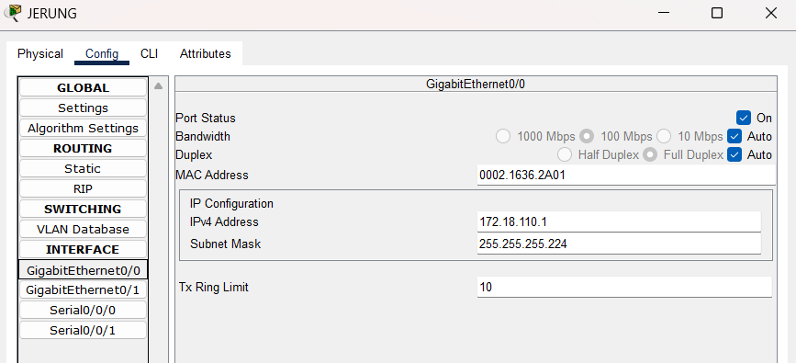
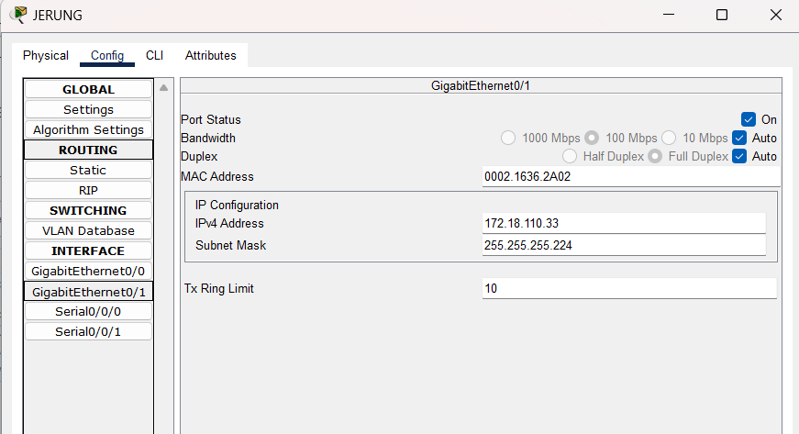
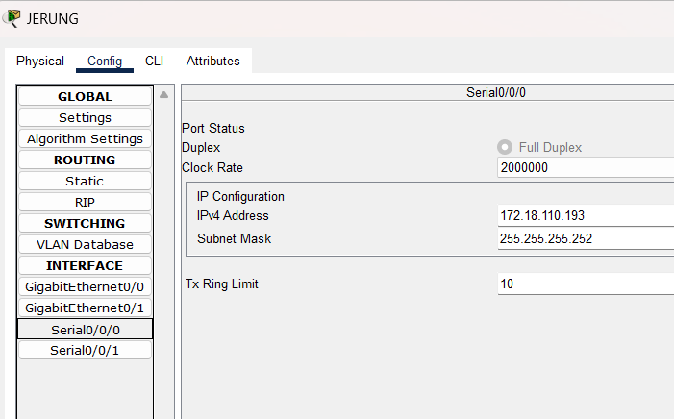
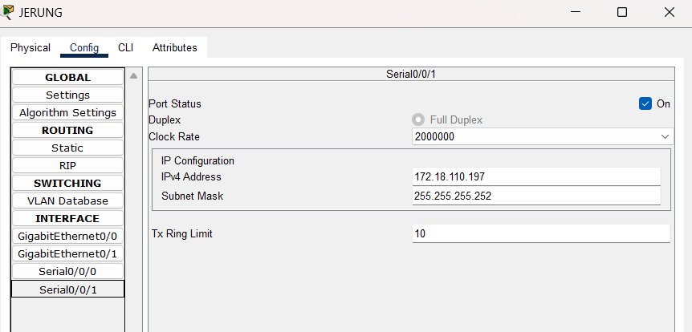

TIBURON:
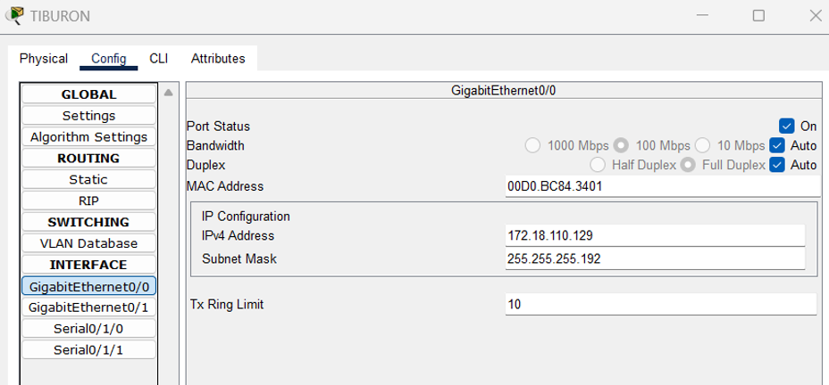
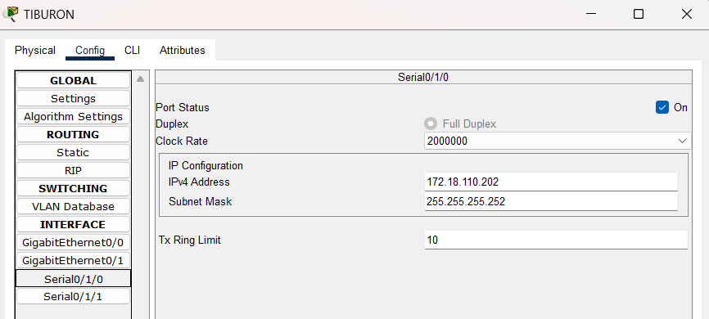
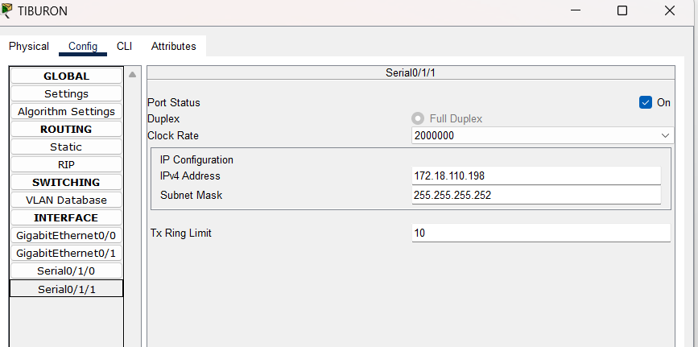
SHARK:
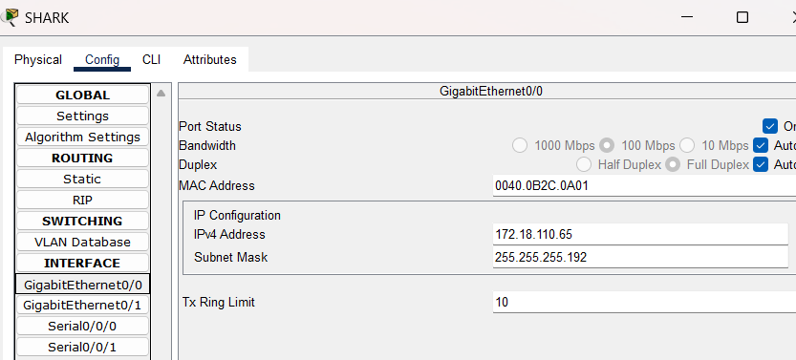
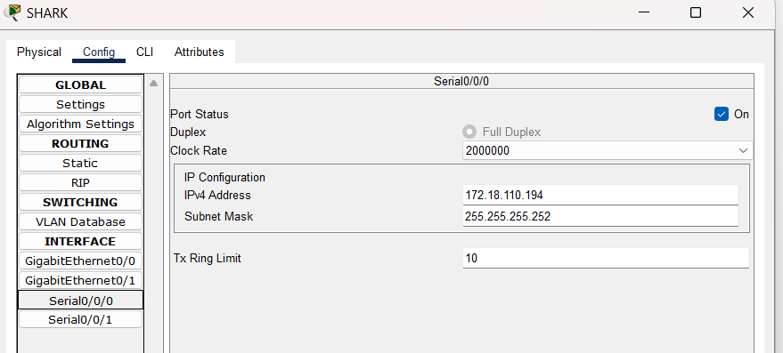
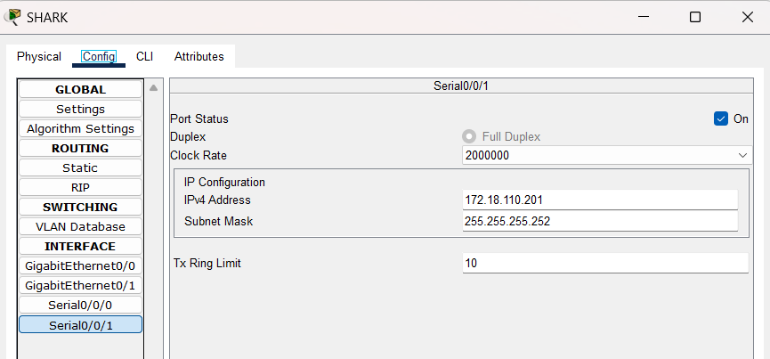

PC1:
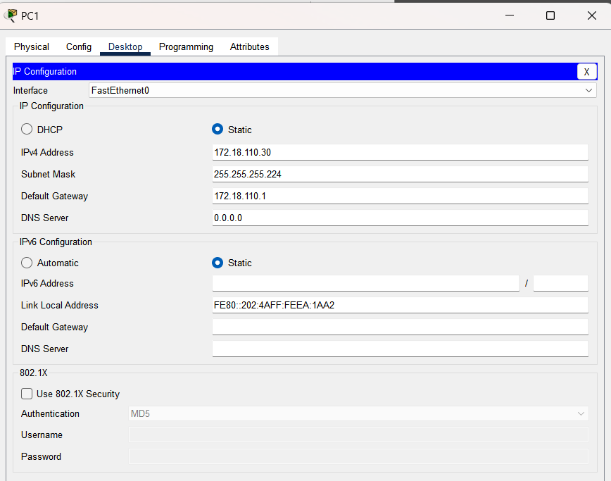

PC2:
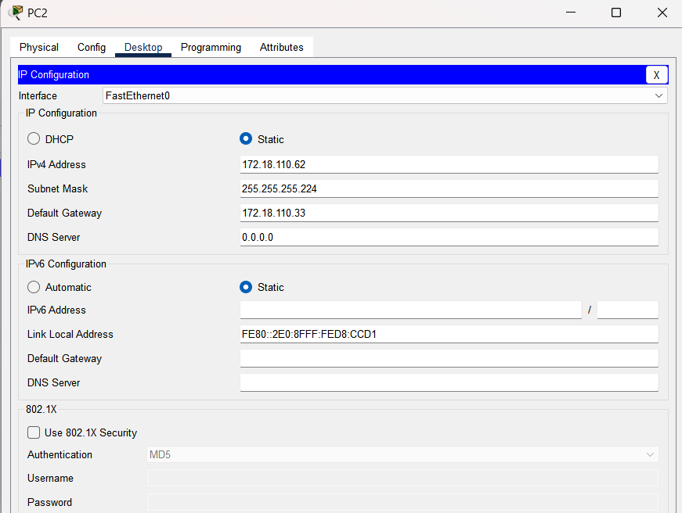

PC3:
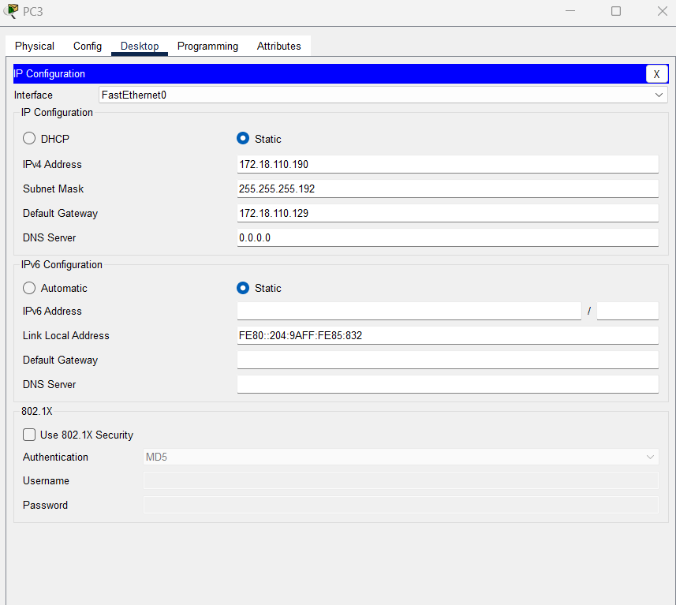

PC4:
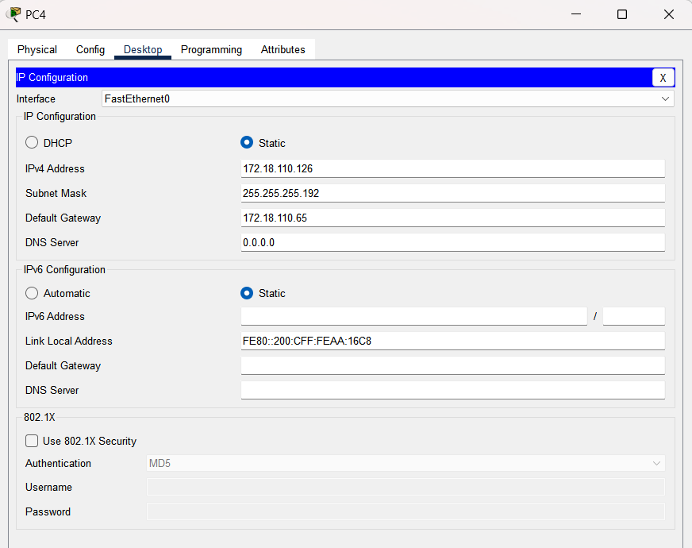

Task 2 – Routing Table
- Paste the current routing table of each router here. There are 2 ways to this – via CLI and via Packet Tracer (PT) tool. Use both ways to show the routing table of all the routers.
  - CLI
    - Click on a router. In the prompt, type show ip route. The routing table of the router will be shown, as shown in Figure A.
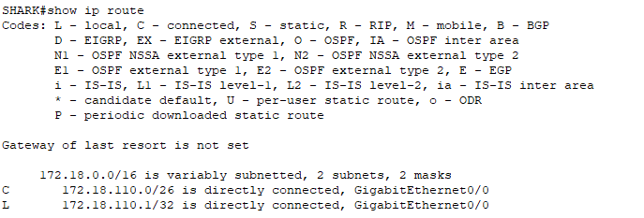
Figure A
  - PT tool
    - Click on the magnifying glass (shown in Figure B), then click on a router, then choose Routing Table. A sample of the result is shown in Figure C.

Figure B
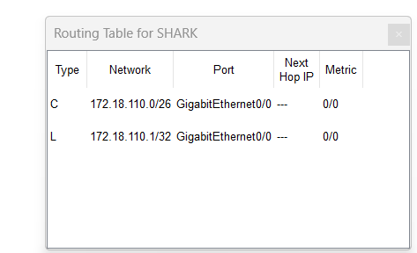
Figure C

JERUNG
CLI:
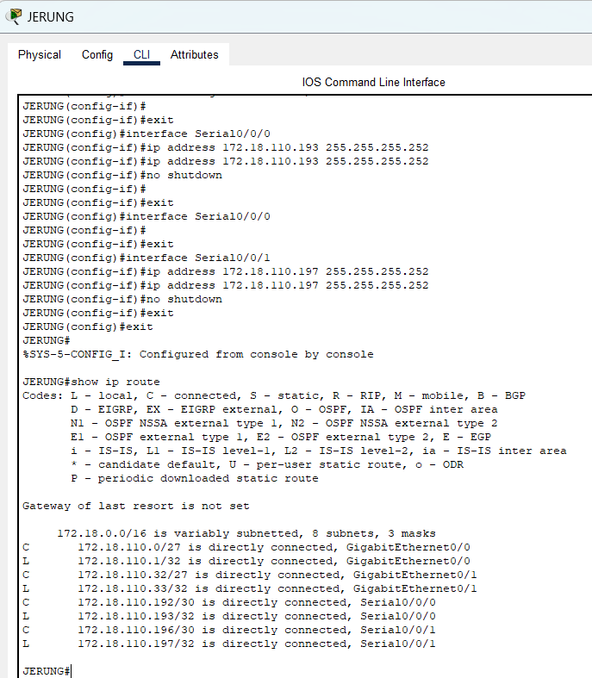
PT Tool:
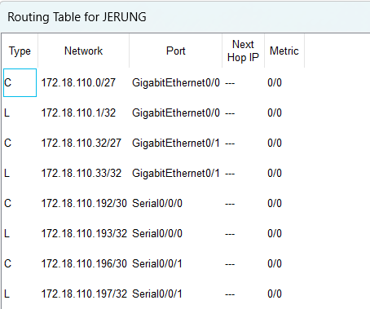

TIBURON
CLI:
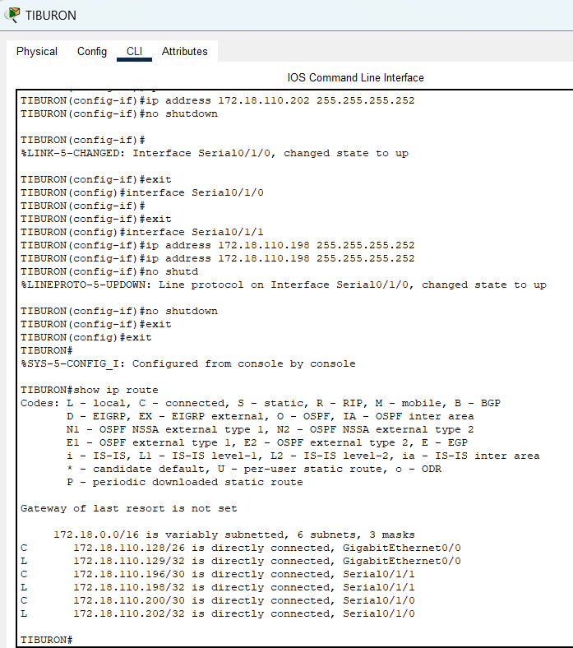

PT Tool:
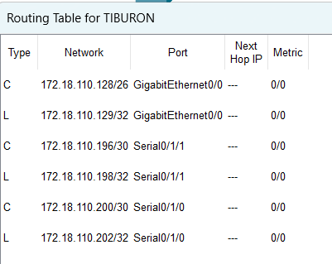

SHARK
CLI:
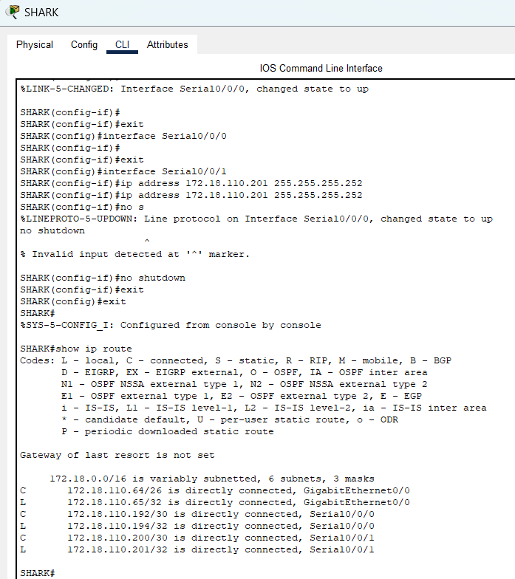
PT Tool:
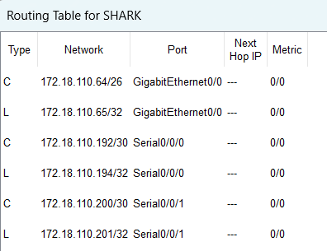

- Try to ping PC2 from PC1, paste the results here.
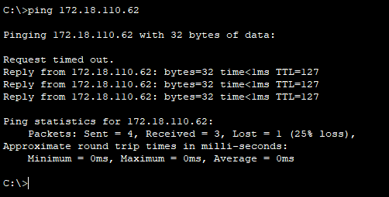

- Try to ping PC4 from PC1, paste the results here.
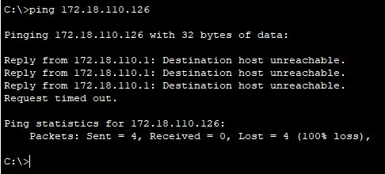

- Explain the reason(s) behind the results.

PC1 ping PC2 successfully because they are in the same subnet. However, PC1 failed to ping PC4 because they are in different subnets causing them unable to communicate directly to each other and there is no configurations that enables devices in different subnets to communicate across different router. Also, PC1 and PC4 are connected to different routers thus the result shows “Destination host unreachable”.

- What needs to be done to ensure all PCs can ping each other successfully?

- All interfaces must have the proper IP addresses and subnet masks.
- Default gateways must be configured on all PCs.
- Verify that no access control lists (ACLs) are blocking communication.
- RIP or static routes must be configured so that routing information can be shared between routers.

Task 2 – Routing Configuration
- Let’s start by opening the routing table (using the PT tool) for TIBURON and JERUNG. This is done to show changes to the routing table as configurations are made.
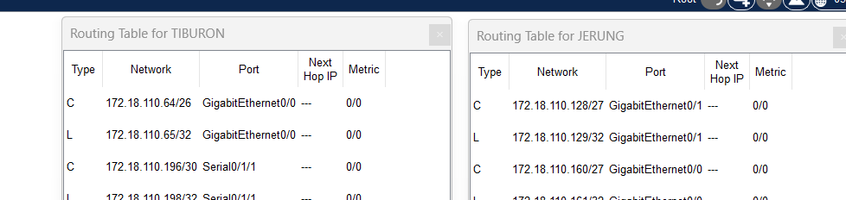
Figure D
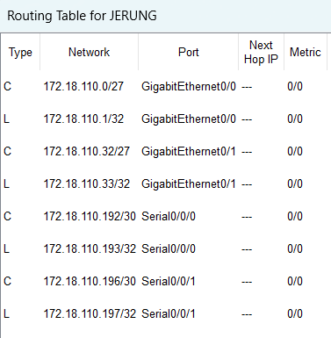
- In router JERUNG, configure the RIP routing protocol as shown in Figure E.
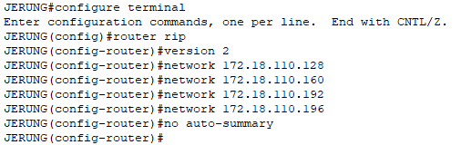
Figure E

JERUNG:
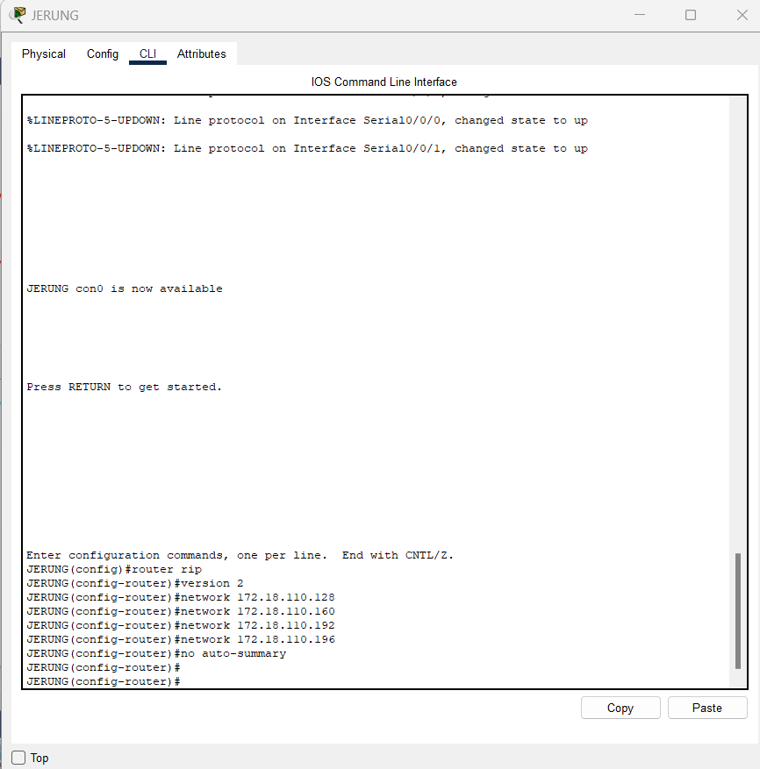
  - What can you say about the addresses used in the ‘network’ instructions in Figure E?
The addresses in the 'network' instructions are the starting points for different IP ranges (subnets). Adding these network addresses in RIP lets routers share information about how to reach each subnet. This allows devices in different subnets and routers to communicate with each other efficiently.

- Then configure RIP in TIBURON. All are similar except use the network address. Use the instructions as shown below.
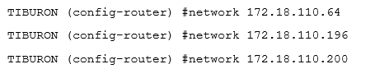
TIBURON:
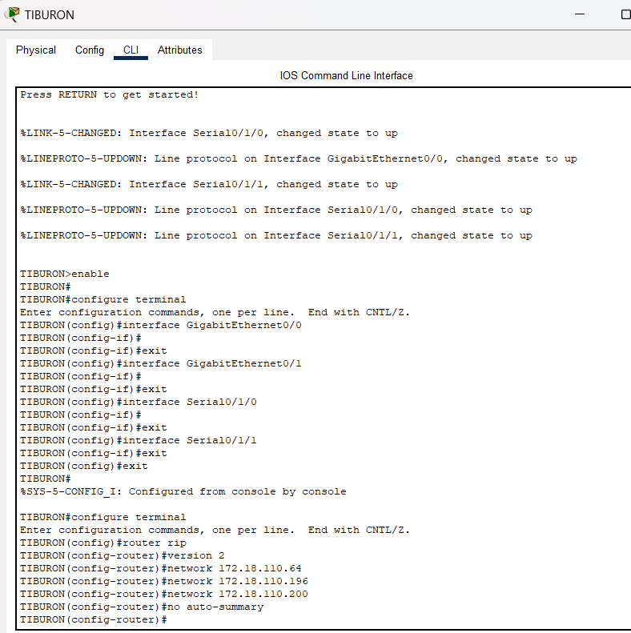

- As you may have seen, there are changes in the routing tables of both TIBURON and JERUNG. Paste a copy of these routing tables here.

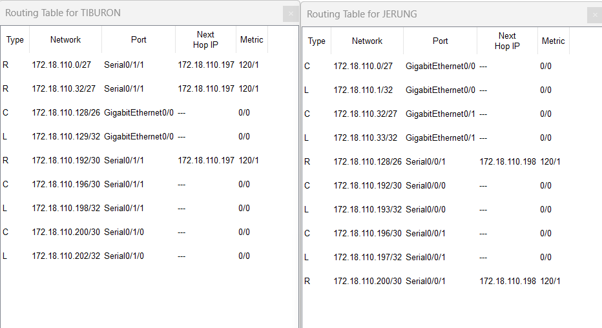

  - What are the changes seen in TIBURON?
Before RIP, the routing table only showed directly connected networks. After RIP, TIBURON’s table includes RIP-learned routes (R) for the networks connected to JERUNG and SHARK.

  - What are the Networks with type R in TIBURON and JERUNG?

TIBURON: 172.18.110.0/27, 172.18.110.32/27, and 172.18.110.192/30
JERUNG: 172.18.110.128/26, and 172.18.110.200/30

  - Ping PC3 from PC1. Was it successful?
Yes
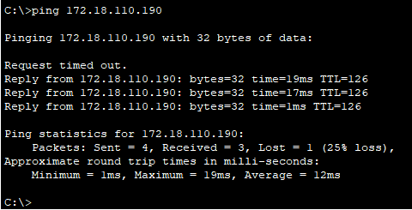

  - Ping PC4 from PC1. Was it successful?
Not successful
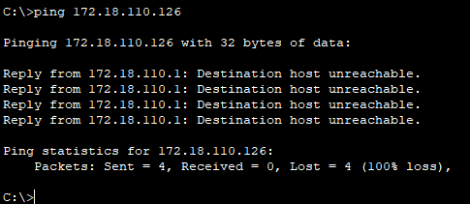

  - Explain the reasons for your answer.

- PC1 Successfully Pings PC3: Both PCs (PC1 and PC3) are in subnets directly connected to the JERUNG router. JERUNG can route between its interfaces because it inherently knows the routes for its directly connected subnets.

- PC1 Fails to Ping PC4: PC1 and PC4 are in different subnets and are not directly connected to the same router. PC1 is connected to JERUNG, and PC4 is connected to SHARK. SHARK does not have RIP configured, so it cannot share or learn routing information for PC4's subnet. This lack of configuration prevents JERUNG from knowing how to route packets to PC4's network.

  - Continue with configuration of RIP in SHARK. Paste your configurations here.
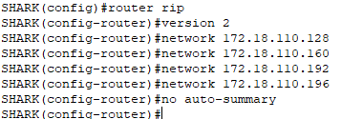

  - Open router SHARK’s routing table and paste here.

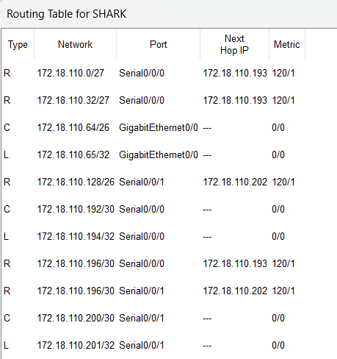

  - Try to ping from PC4 to all other PCs in the topology. *Note: Try to ping at least twice to get best results.
PC | Ping result
1 | Success  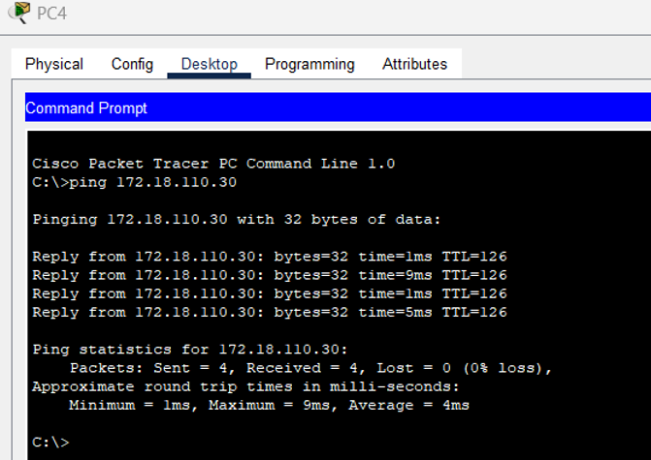
2 | Success  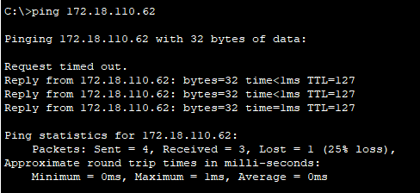
3 | Success  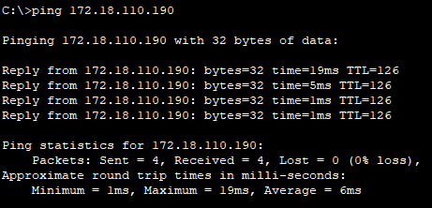

Task 3 – Routing Update
- Let’s try a little experiment. Change the IP addresses of router TIBURON interface G0/0 to 192.168.1.1/24.

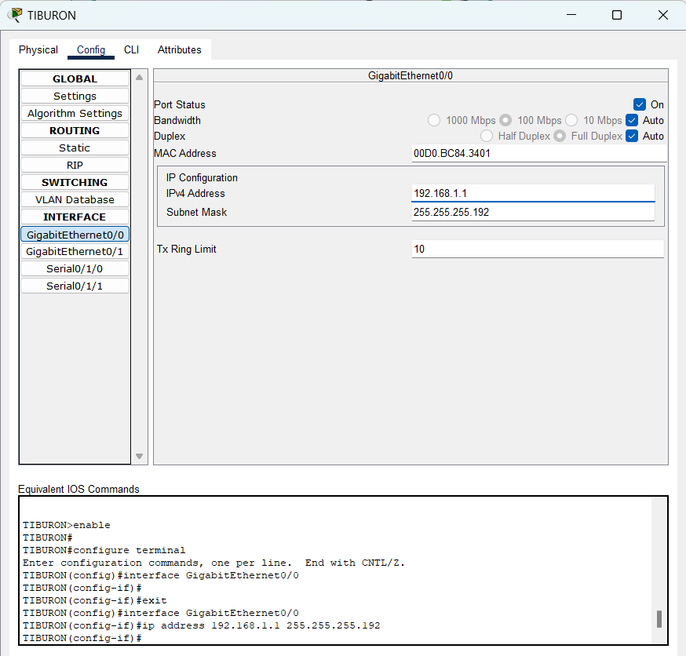

  - This means that the subnet has changed. Find the new Network address of this subnet. Network Address is: 192.168.1.0/24

  - As this change happens, PC3 must also have different IP address, subnet mask and gateway address. What will it be?
PC3 | Info
IP address | 192.168.1.254
Subnet Mask | 255.255.255.0
Gateway Address | 192.168.1.1
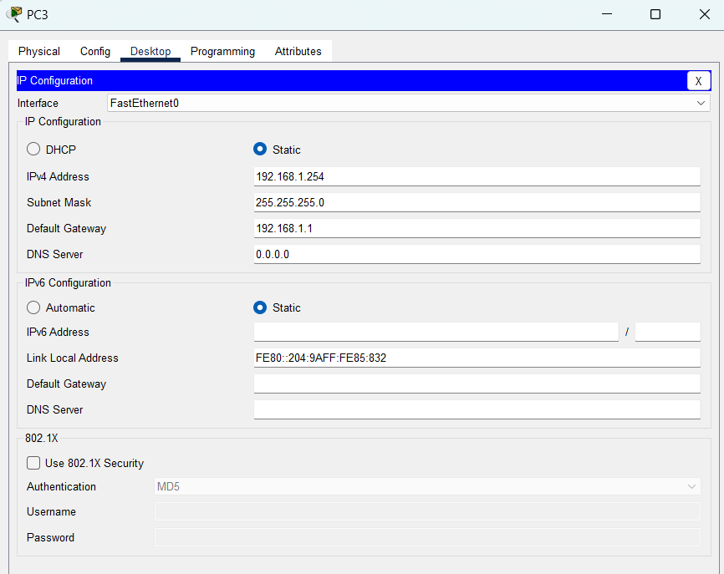
  - After this change, can PC4 and PC1 ping PC3?
Both PC4 and PC1 cannot ping PC3

PC1:

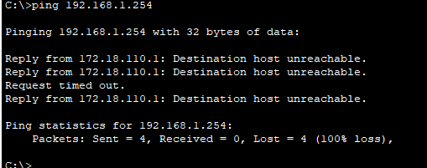

PC4:

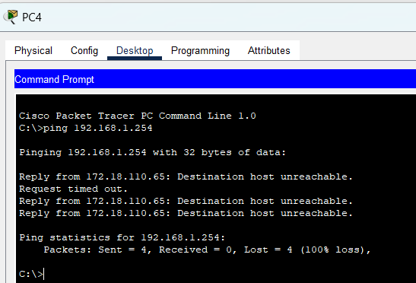

  - Copy and paste the routing tables for both SHARK and TIBURON here.
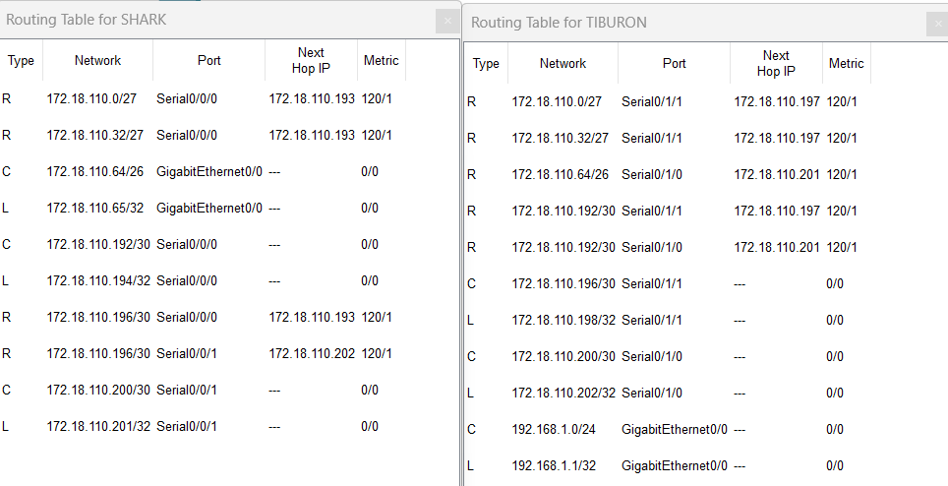

  - Referring to the routing table, explain your findings.

SHARK’s routing table does not include 192.168.1.0/24 subnet, whereas TIBURON’s routing table includes the 192.168.1.0/24 subnet. This causes PC4 and PC1 cannot ping PC3 successfully. JERUNG and SHARK need to add the 192.168.1.0/24 subnet in their routing table so that all devices an communicate successfully across different subnets.

  - What is your next move to ensure end-to-end connectivity (i.e. all PCs can ping each other successfully)?

Ensure all routers have the correct network statements in RIP to propagate 192.168.1.0/24. This can be done by updating RIP on TIBURON and propagate the new route for other subnets.

  - Show your configurations in TIBURON to ensure end-to-end connectivity.
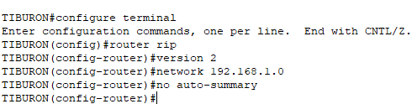

- The network 192.168.1.0 command tells the router to advertise and learn routes in this subnet range.

  - To ensure end-to-end connectivity, ping to all the PCs from PC3.
PC | Ping result
1 | Success
2 | Success
4 | Success

PC1
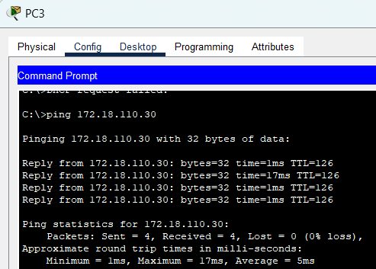

PC2
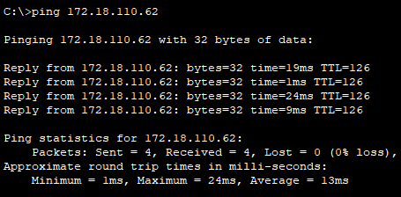
PC4
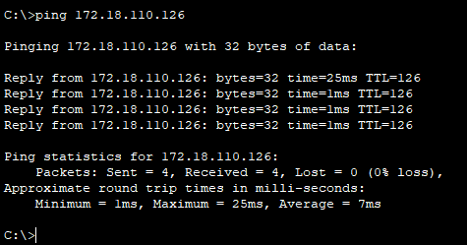

REFLECTION
What have you learned in this task?
From this task, I learned how to configure routers using RIP to enable communication between different subnets. I also understood the importance of subnetting for efficient IP address allocation and how dynamic protocols like RIP simplify routing between routers. Additionally, I learned how to troubleshoot connectivity issues using commands like "ping" and "show ip route." This task helped improve my understanding of routing protocols and their configuration.

